

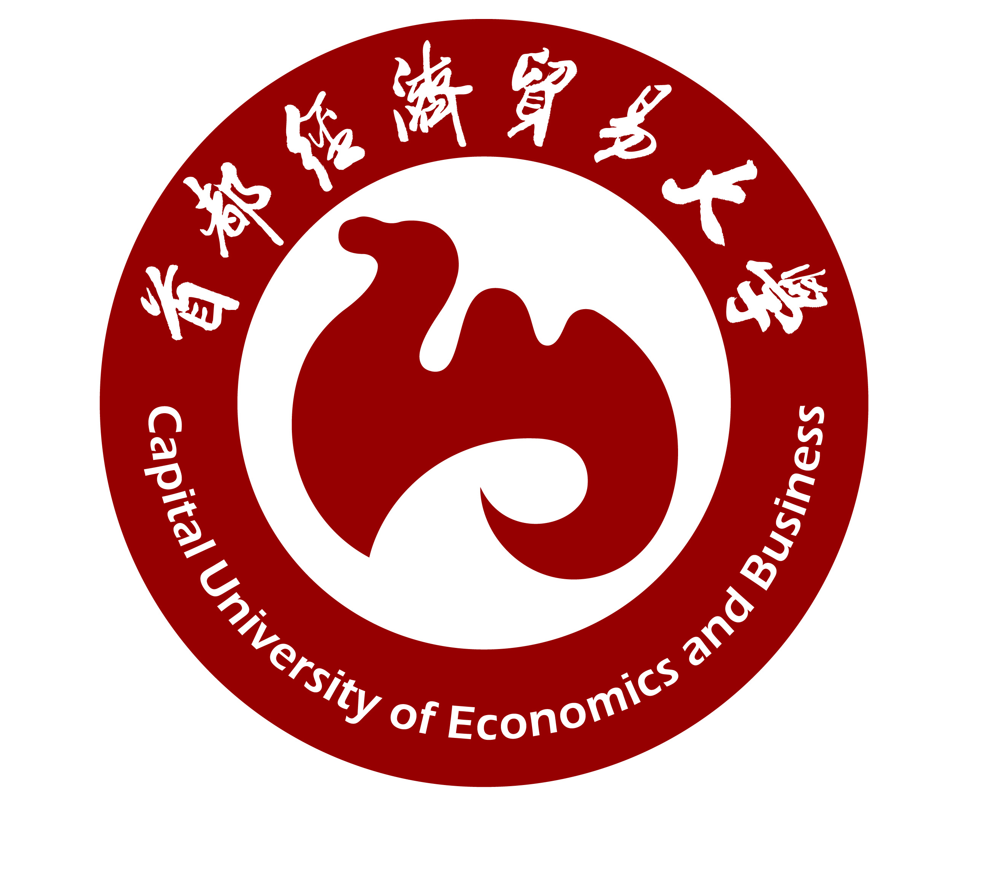
Overseas Chinese College

Application Form
证书实验班申请表
Applicant/申请人： Students ID./学号：
Score/高考总分： English Score/高考英语成绩：
工商管理（国际会计） 请在括号内打“√”

证书实验班类型：ACCA（ ）
信息管理与信息系统（金融信息管理） 请在括号内打“√”

证书实验班类型：CFA （ ）
Note: Students with outstanding academic records, willingness to learn, and a clear study plan may apply to the ACCA/CFA Programs on their own initiative. Decisions on admission will be made after a comprehensive assessment process of written tests, interviews, and so on. Candidates who voluntarily pay certificate program costs per school year shall be permitted to enter into the Program. Students who voluntarily withdraw or are washed out eliminated from the experimental class may need to retake or take additional courses due to curriculum differences with the ordinary programs , This could delay their graduation time, and they will not be entitled to get a refund. Refer to the refund policy in the catalog.
注：凡学习成绩优秀并自愿增加学习内容，明确学习方向的学生，根据自身情况递交申请。在经过统一安排的笔试、面试等综合评估后，择优限额录取。凡录取者自愿缴纳证书培训费用（不含注册费、年费、全球考试费等），方可进入英文教学ACCA /CFA证书实验班学习。退出或被淘汰出证书实验班时，由于课程的设置不同，有可能导致重修、补修课程的困难以致延长毕业时间。已发生的证书班培训费用不予退还，详见《Catalog》退费规定。
Signature/学生签字: Signature/家长（知情）签字:
（在确认家长知情的情况下，可由班主任代签）

ACCA Fee 费用12000.00/学年：

CFA Fee 费用9500.00/学年：

Cashiers Stamp/财务盖章：

NOTE: The students must return this form to Student Service Center when they finish the procedure, otherwise the form will be treated as invalid.注：学生完成以上程序后，将此单交回教务管理办公室，否则视此单为无效。

Date of Application/申请日期：

